Methods

Our data includes cortical, subcortical, and DTI measurements totaling 66 features for 76 instances in the control group. All data was scaled feature-wise using standard deviations from the mean. The coefficient of determination $R^{2}$ was used to determine model fit as opposed to average age difference such that variance is accounted for.

$$R^{2}=\frac{\sum{{{(y}_{true}-y_{predicted})}^{2}}}{\sum{{{(y}_{true}-y_{true}.mean())}^{2}}}$$

Note that this allows negative $R^{2}$ values, which simply implies that a model estimating the mean of the sample points would have done better.

Software used for statistical analysis includes Python 3.6.8 64bit, scikit-learn, numPy, and matplotlib.

Analysis started with single variable regression against age, where the strongest correlations were linear and had an $R^{2}$ value just below 0.2. The five variables most highly correlated with age include *superiorfrontal* ($R^{2}$ = 0.192), *GCC* ($R^{2}$ = 0.169), *parsopercularis* ($R^{2}$ = 0.163), *medialorbitofrontal* ($R^{2}$ = 0.157), and *thalamus* ($R^{2}$ = 0.151).

Next, we determine which model for predicting age performed best. Models were tested with different input features selected. We see a uniform distribution of ages among the training dataset, so cross validation with random sampling from a shuffled dataset is used for model assessment. 5-fold cross validation is used, giving training sets of 61 and test sets of 15. This cross validation was done 100 times on each model, with seeded random splits such that each model saw the same splits during training and fitting. For each cross validation, an average score was taken from the 5 configurations. Then, those averages were averaged after 100 iterations.

When using the full feature vector of 66 features, a Bayesian ridge model performed best, averaging $R^{2}$ =0.609 over 100 iterations of 5-fold cross validation, showing the best ability to generalize. When fitting the model to the entirety of the dataset, we see $R^{2}$ =0.883. Other notable models using the full feature vector include SVM with RBF kernel ($R^{2}$ =0.536), ElasticNet ($R^{2}$ =0.593), and ridge ($R^{2}$ =0.516).

Subsets of the feature vector were also experimented with. These subsets include the cortical feature vector, subcortical feature vector, DTI feature vector, the top 5 variables linearly correlated with brain age, and the top 20 variables linearly correlated with age. The same models were trained in the same fashion described above, but no other subset of data performed as well as the full feature vector with a Bayesian ridge regressor model.

Ridge regression vastly outperformed ordinary least squares regression during cross validation, showing that there may be collinearity in the data. This can be expected, as the features represent brain regions which are close spatially. A reading for one area may be influenced by those around it. Ridge regression also shifts the coefficient weights toward 0, which can help stabilize them.

The Bayesian ridge inference model working better than ridge alone implies that there may be priors associated with the input data, which may be induced from the equipment that performed the brain scans to take this data, or the brain’s activity itself. Non-informed priors are used in this implementation of Bayesian ridge regression, assuming a Gaussian distribution around the feature vectors. The Bayesian inference model may also be performing better due to the smaller sample size, allowing for the priors to have significant impact on the resulting predicted age.

|  |  |  |  |
| --- | --- | --- | --- |
| **Feature** | $R^{2}$**Linear** | $R^{2}$**deg=2** | $R^{2}$**deg=3** |
| superiorfrontal | 0.191806974 | 0.190957297 | 0.153828254 |
| GCC | 0.168573645 | 0.185481251 | 0.143588608 |
| parsopercularis | 0.162543893 | 0.148481573 | 0.107115252 |
| medialorbitofrontal | 0.156666067 | 0.144221257 | -0.102068301 |
| Thalamus | 0.151453842 | 0.154285246 | 0.126686093 |
| superiortemporal | 0.138638063 | 0.12829608 | 0.112861574 |
| rostralanteriorcingulate | 0.122889494 | 0.104477196 | 0.062824869 |
| CC | 0.109873238 | 0.11081502 | 0.085506722 |
| BCC | 0.105178546 | 0.099159928 | 0.059506878 |
| Left-Accumbens-area | 0.101227941 | 0.100850562 | -0.441981323 |
| FX | 0.084414875 | 0.075922113 | 0.042183436 |
| caudalmiddlefrontal | 0.078756231 | 0.033309392 | -0.097988119 |
| insula | 0.071186958 | 0.070307634 | 0.058560935 |
| supramarginal | 0.067991748 | 0.051994474 | -0.055696737 |
| frontalpole | 0.062361593 | 0.038629688 | -0.01095099 |
| rostralmiddlefrontal | 0.060488917 | 0.04040489 | -0.046457459 |
| parstriangularis | 0.059285932 | 0.062792963 | 0.027704727 |
| bankssts | 0.052170539 | 0.058758916 | -0.028086754 |
| CR | 0.022410172 | 0.01812194 | 0.010100561 |
| lateralorbitofrontal | 0.015881764 | -0.037889873 | -0.092436024 |

Figure: Table of the top 20 variables linearly related with age

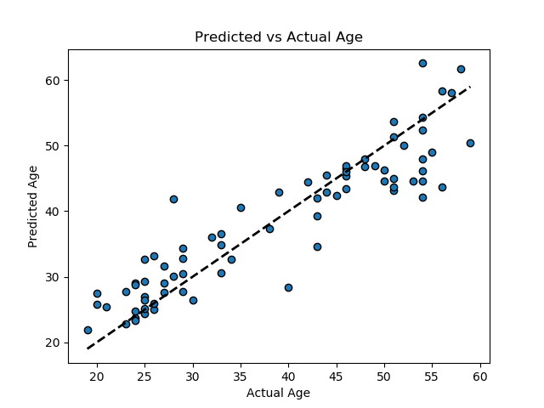

Figure: Predicted vs Actual Age for a Bayesian Ridge Regression model trained on all 76 samples ($R^{2}$ =0.883)

|  |  |
| --- | --- |
| Model | $$R^{2}$$ |
| Bayesian Ridge | 0.609 |
| SVM - RBF | 0.536 |
| Linear Regression | -3.647 |
| Decision Tree | -0.37 |
| Ridge | 0.516 |
| Lasso | 0.383 |
| ElasticNet | 0.593 |
| SGD | 0.066 |

Figure: Model scores averaged over 100 iterations of 5-fold cross validation on the full feature vector